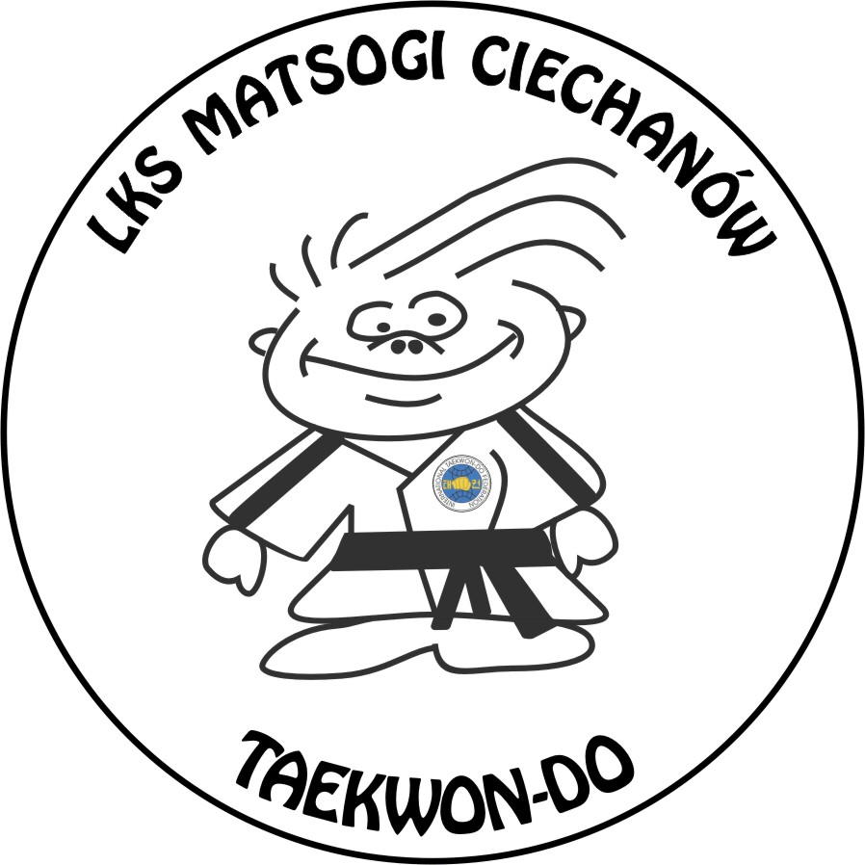
Ludowy Klub Sportowy MATSOGI CIECHANÓW
06-400 Ciechanów ul. Warszawska 28
Tel. kom +48 607 133 234, e-mail: mkorzybski@wp.pl, www.matsogi.pl
Konto: Bank Spółdzielczy w Ciechanowie 84821300082001000487120001

Ciechanów 24th August 2008

International Taekwon-do Tournament
MASTERS MAZOVIA Cup2008
Ciechanów 8th November 2008

Announcement
- Name of the Championships - International Taekwon-do Tournament
MASTERS MAZOVIA CUP 2008
- Aim:
  - The celebration of 20 years existence of Taekwon-do in Ciechanow City
  - Promotion of Taekwon-do on the area of Ciechanow City and Mazovia Voivodeship
  - Promotion of Ciechanow City and Mazovia Area abroad of Poland
- Organizer:
  - LKS Matsogi Ciechanów,
  - Polish Taekwon-do Association,
  - Voivodeship of Mazovia Marshal Office
  - the Municipality of Ciechanów City
  - City Sport Centre of Ciechanów,
- Host:
  - LKS MATSOGI CIECHANÓW,
- Patronage:
  - Mr. Adam Struzik – Marshal of Mazovia Area,
  - Mr. Waldemar Wardziński – President of Ciechanów City;
- Media patronage:
  - Radio KRC Ciechanów 103,9 FM;
  - Newspapers: Tygodnik Ciechanowski, Czas Ciechanowa;
- Time and place:
  - 7th - 8th November 2008 (Friday, Saturday)
  - Sport Hall MOSIR Ciechanow
17-go Stycznia Street 60 (Tournament office)

- Accommodation and board:
- HOTEL „Olimpijski” 17-go Stycznia Street 60, (part of sport complex MOSIR Ciechanow, 50 meters from the sport hall

- HOTEL „ Baron” – Śląska Street 11, ca. 700 meter from the sport hall,

- Triple four rooms with bathroom – 20 Euro/ a person/ a day with breakfast,
- Double rooms with bathroom – 30 Euro/ a person/ a day with breakfast,
- Single rooms with bathroom – 40 Euro/ a person/ a day with breakfast,

- Timetable of the tournament:
7th November 2008 (Friday)
from 13.00 - arrival of competitors
15.00 - 20.00 - Weight in and doctor’s examination (Sport Hall MOSiR),
20.00 - 20.30 - coaches meeting (Sport Hall MOSiR)

8th November 2008 (Saturday)
7.00 - 8.00 - breakfast (in hotels)
8.30 -9.00 - umpires meeting (Sport Hall MOSIR)
10.00 - 15.00 - qualifiers
15.00 - 17.30 - break
17.30 - meeting of competitors participating in the Gala MMC 2008
18.00 - 20.00 - GALA MASTERS MAZOVIA CUP 2008
21.00 - Banquet for invited people/ party for competitors – Baron Hotel

9th November 2008 (Sunday)
08.00 – 9.00 - breakfast (in hotels)
09.00- 12.00 - departure,

- Participation conditions:
Payment of the entry fee of 20 Euro / competitors or pair (traditional sparring)

- Competition rules:
The championships will be played according to the Rules of ITF and PTA
Age of competitors: Seniors 18 years old or older (born in 1990 and earlier)
For black belts only.

- INDYWIDUAL SPARRING – the organizer funded in every sparing categories cash prices:
I place – 500 Euro,
II place – 250 Euro,
III place – 100 Euro ( two 3rd places);
- Advanced senior female (1st – 6th Degree): up to 63 kg,
- Advanced senior male (1st – 6th Degree): up to 63 kg/ 71 kg/ 80 kg;
- In every weight class the organizer will invite at its expenses two best competitors of Europe (Champion and Vice-Champion of the last Euros 2008 in Wroclaw) as well as their coaches.
- Other competitors have to cover the expenses.
- 4 competitors selected in the qualifiers in each weight class will take part in the final MMC Gala 2008 (semifinals and finals 2x2min)
- 5-15 competitors ( qualifiers in the groups - Pool Match Group (1x2min), groups 3-5 competitors),
- 16 competitors and more – “repasage system” up to two losses (first match -2x2min, repasage match – 1x2 min)
- Entry fee 20 Euro/ competitor,

- TRADITIONAL SPARRING
- Two best pairs will get to the Final MMC Gala 2008,
- The performance should last ca. 1 minute
- The competition will be played in the traditional „pyramid system”.

- SPECIAL TECHNIQUES (men’s only)
- Competitors will perform only one technique: nopi ap cha busigi,
- 4 best competitors will go to the final MMM Gala 2008,
- Minimum height: 240 cm,
- Prices:
  - Certificates of participation for every competitor, medals and diplomas for 1st, 2nd, 2 x 3rd places, Trophies for the best competitor in each category.
- Other matters:
  - The qualifiers will be held on three fight squers. The competitors have to be in possession of safety equipment: boxing gloves (10 OZ), kicks – foot safety pads, ITF dobok, groin guards must be worn inside the dobok trousers – male only
  - There have to be at least 4 competitors, pairs in every category. In case if there will be less then 4 competitors in category, the organizers have right to cancel the category
  - Competitors, who have paid entry fee in sparring, don’t have to pay entry fee in special techniques or traditional sparring.
  - The Chairman of the Competition will decide about the matters not written in this announcement.
  - There is possibility to arrange transport from the Warsaw Airport to Ciechanow and back – ca. 20 Euro.
- Applications:
  - Applications have to be send before or on the 10th October 2008 to the e-mail address: mkorzybski@wp.pl
  - The person responsible for the organization is: Mr. Michal Korzybski:
mobile phone: +48607133234 or email: mkorzybski@wp.pl
  - In case of any question please contact Master Jerzy Jedut:
mobile +48603133228 or email jjedut@pztkd.lublin.pl

Attention!
The organizer will not secure accommodation and board for the competitors or schools that send applications after the deadline: 10th October 2008
The competitors have to be insured
in case of after-effect of unfortunate accidents.

Mr. Michal Korzybski
Chairman
the Organizing Committee
MASTERS MAZOVIA CUP 2008

